62443-3-3 © IEC:2013(E) – 11 –
Provided by : www.spic.ir

Introduction

Overview
NOTE 1 This standard is part of series of standards that addresses the issue of security for industrial automation and control systems (IACS). It has been developed by working group 4, task group 2 of the IEC99 committee in cooperation with IEC TC65/WG10. This document prescribes the security requirements for control systems related to the seven foundational requirements defined in IEC 62443‑1‑1 and assigns system security levels (SLs) to the system under consideration (SuC).

NOTE 2 The format of this standard follows the ISO/IEC requirements discussed in ISO/IEC Directives, Part 2 [11]. 1 These directives specify the format of the standard as well as the use of terms like “shall”, “should”, and “may”. The requirements specified in normative clauses use the conventions discussed in Appendix H of the ISO/IEC Directives.

Industrial automation and control system (IACS) organizations increasingly use commercial- off-the-shelf (COTS) networked devices that are inexpensive, efficient and highly automated. Control systems are also increasingly interconnected with non-IACS networks for valid business reasons. These devices, open networking technologies and increased connectivity provide an increased opportunity for cyber attack against control system hardware and software. That weakness may lead to health, safety and environmental (HSE), financial and/or reputational consequences in deployed control systems.

Organizations deploying business information technology (IT) cyber security solutions to address IACS security may not fully comprehend the results of this decision. While many business IT applications and security solutions can be applied to IACS, they need to be applied in an appropriate way to eliminate inadvertent consequences. For this reason, the approach used to define system requirements needs to be based on a combination of functional requirements and risk assessment, often including an awareness of operational issues as well.

IACS security measures should not have the potential to cause loss of essential services and functions, including emergency procedures. (IT security measures, as often deployed, do have this potential.) IACS security goals focus on control system availability, plant protection, plant operations (even in a degraded mode) and time-critical system response. IT security goals often do not place the same emphasis on these factors; they may be more concerned with protecting information rather than physical assets. These different goals need to be clearly stated as security objectives regardless of the degree of plant integration achieved. A key step in risk assessment, as required by IEC 62443‑2‑12, should be the identification of
which services and functions are truly essential for operations. (For example, in some
facilities engineering support may be determined to be a non-essential service or function.) In some cases, it may be acceptable for a security action to cause temporary loss of a non- essential service or function, unlike an essential service or function that should not be adversely affected.

This standard assumes that a security program has been established and is being operated in accordance with IEC 62443‑2‑1. Furthermore, it is assumed that patch management is implemented consistently with the recommendations detailed in IEC/TR 62443‑2‑3 [5] utilizing the appropriate control system requirements and requirement enhancements as described in this standard. In addition, IEC 62443‑3‑2 [8] describes how a project defines risk-based security levels (SLs) which then are used to select products with the appropriate technical security capabilities as detailed in this standard. Key input to this standard included
ISO/IEC 27002 [15] and NIST SP800-53, rev 3 [24] (see Clause 2 and the Bibliography for a more complete listing of source material).

- Numbers in square brackets refer to the Bibliography.
- Many documents in the IEC 62443 series are currently under review or in development.

– 12 – 62443-3-3 © IEC:2013(E)
Provided by : www.spic.ir

The primary goal of the IEC 62443 series is to provide a flexible framework that facilitates addressing current and future vulnerabilities in IACS and applying necessary mitigations in a systematic, defensible manner. It is important to understand that the intention of the IEC 62443 series is to build extensions to enterprise security that adapt the requirements for business IT systems and combines them with the unique requirements for strong availability needed by IACS.

Purpose and intended audience
The IACS community audience for this standard is intended to be asset owners, system integrators, product suppliers, service providers and, where appropriate, compliance authorities. Compliance authorities include government agencies and regulators with the legal authority to perform audits to verify compliance with governing laws and regulations.

System integrators, product suppliers and service providers will use this standard to evaluate whether their products and services can provide the functional security capability to meet the asset owner’s target security level (SL-T) requirements. As with the assignment of SL-Ts, the applicability of individual control system requirements (SRs) and requirement enhancements (REs) needs to be based on an asset owner’s security policies, procedures and risk assessment in the context of their specific site. Note that some SRs contain specific conditions for permissible exceptions, such as where meeting the SR will violate fundamental operational requirements of a control system (which may trigger the need for compensating countermeasures).

When designing a control system to meet the set of SRs associated with specific SL-Ts, it is not necessary that every component of the proposed control system support every system requirement to the level mandated in this standard. Compensating countermeasures can be employed to provide the needed functionality to other subsystems, such that the overall SL-T requirements are met at the control system level. Inclusion of compensating countermeasures during the design phase should be accompanied by comprehensive documentation so that the resulting achieved control system SL, SL-A(control system), fully reflects the intended security capabilities inherent in the design. Similarly, during certification testing and/or post- installation audits, compensating countermeasures can be utilized and documented in order to meet the overall control system SL.

There is insufficient detail in this standard to design and build an integrated security architecture. That requires additional system-level analysis and development of derived requirements that are the subject of other standards in the IEC 62443 series (see 0). Note that providing specifications detailed enough to build a security architecture are not the goal of this standard. The goal is to define a common, minimum set of requirements to reach progressively more stringent security levels. The actual design of an architecture that meets these requirements is the job of system integrators and product suppliers. In this task, they retain the freedom to make individual choices, thus supporting competition and innovation. Thus this standard strictly adheres to specifying functional requirements, and does not address how these functional requirements should be met.

Usage within other parts of the IEC 62443 series
Figure 1 shows a graphical depiction of the IEC 62443 series when this standard was written.

IEC 62443‑3‑2 uses the SRs and REs as a checklist. After the system under consideration (SuC) has been described in terms of zones and conduits, and individual target SLs have been assigned to these zones and conduits, the SRs and REs in this standard, as well as their mapping to capability SLs (SL-Cs), are used to compile a list of requirements which the control system design needs to meet. A given control system design can then be checked for completeness, thereby providing the SL-As.

62443-3-3 © IEC:2013(E) – 13 –
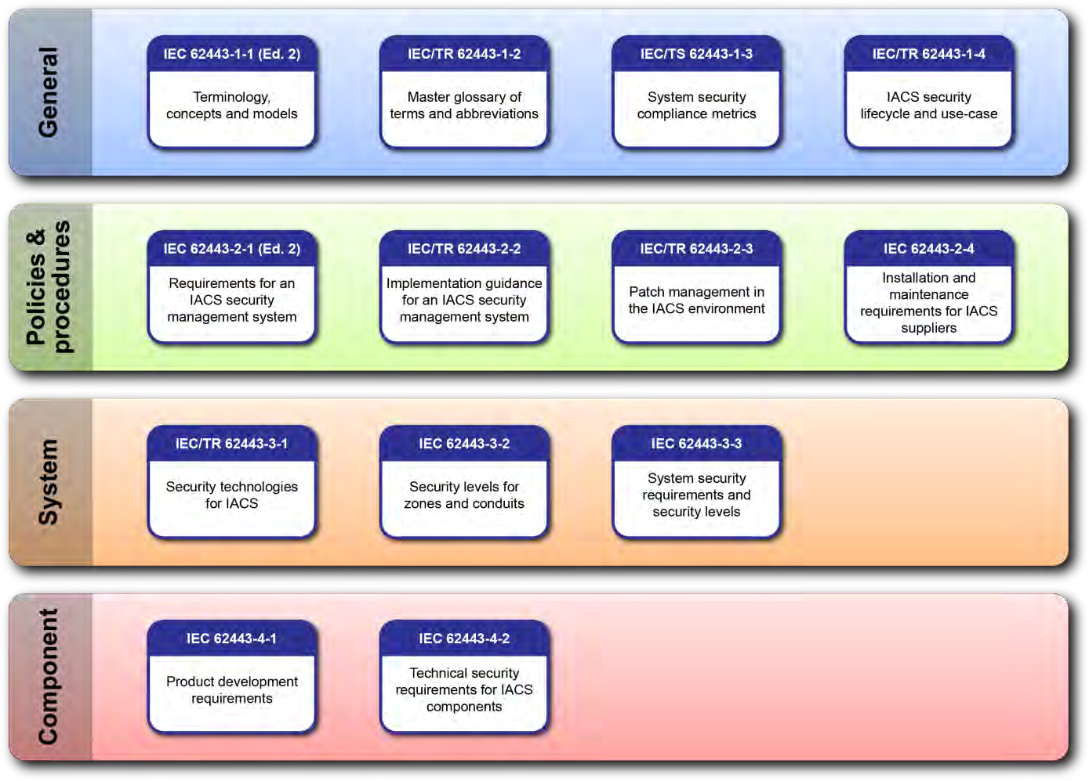

Figure 1 – Structure of the IEC 62443 series
IEC 2031/13

Provided by : www.spic.ir
IEC/TS 62443‑1‑3 [2] uses the foundational requirements (FRs), SRs, REs and the mapping to SL-Cs as a checklist to test for completeness of the specification of quantitative metrics. The quantitative security compliance metrics are context specific. Together with IEC 62443‑3‑2, the asset owner’s SL-T assignments are translated into quantitative metrics that can be used to support system analysis and design trade-off studies, to develop a security architecture.

IEC 62443-4‑1 [9] addresses the overall requirements during the development of products. As such, IEC 62443‑4‑1 is product supplier centric. Product security requirements are derived from the list of baseline requirements and REs specified in this standard. Normative quality specifications in IEC 62443‑4‑1 will be used when developing these product capabilities.

IEC 62443‑4‑2 [10] contains sets of derived requirements that provide a detailed mapping of the SRs specified in this standard to subsystems and components of the SuC. At the time this standard was written, the component categories addressed in IEC 62443‑4‑2 were: embedded devices, host devices, network devices and applications. As such, IEC 62443‑4‑2 is vendor (product supplier and service provider) centric. Product security requirements are first derived from the list of baseline requirements and REs specified in this standard. Security requirements and metrics from IEC 62443‑3‑2 and IEC/TS 62443‑1‑3 are used to refine these normative derived requirements.

